V 1.7

CIPRES: The Workbench

WORKBENCH TOOLS
(Creating XML Description for new Tool)

Subject
This document describes how we create an XML representation (based on Pise DTD) for integrating a new tool.
Change History

Author | Date | Version | Comments
Rami Rifaieh | 04/01/08 | V 1.0 | Creation
mamiller | 05/01/08 | V 1.1 | Editing and Expanding; draft
mamiller | 05/06/08 | V 1.2 | Added Terri’s Perl info
terri | 05/16/08 | V 1.3 | Terri Added some examples
mamiller | 06/08/08 | V 1.4 | Correct the description of the <flist> element
mamiller | 07/23/08 | V 1.5 | Add some comments about gathering results
mamiller | 11/13/2008 | no update | added a comment: re Results
mamiller | 10/31/2014 | V 1.6 | Introduced the warns/warn element
mamiller | 7/22/2016 | V 1.7 | Cleaned up for use with the distirbution

Contents
1 Introduction 9
1.1 Taking advantage of XML to avoid rewriting code. 10
2 Pise XML description 11
2.1 <head> element 12
2.2 <command> element 13
2.3 Parameter Definition 14
2.3.1 The <parameter> element 14
2.3.2 Boolean attributes for <parameter> element. 16
2.3.3 Making simple and complex forms 17
2.3.4 Type attributes for the <parameter> element 17
2.3.5 Examples: parameter attributes in code and appearance 19
2.3.5.1 Attribute: ‘InFile’ 19
2.3.5.2 Attribute: ‘Sequence’ 19
2.3.5.3 Attribute: ‘Outfile’ 19
2.3.5.4 Attribute: ‘Results’ 20
2.3.5.5 Attribute: ‘Switch’ 21
2.3.5.6 Attribute: ‘Excl’ 21
2.3.5.7 Attribute: ‘List’ 23
2.3.5.8 Attribute: ‘Integer’ 24
2.3.5.9 Attribute: ‘string’ 25
2.3.5.10 Attribute: ‘Paragraph’ 26
2.3.5.11 Attribute: ‘Float’ 26
2.3.6 Parameter organization. 27
2.3.7 The <paragraph> element 28
2.3.8 Sub-values for the <attributes> element 30
2.3.9 Examples: parameter sub-elements from Pise XML files 33
2.3.9.1 Element: <prompt> 33
2.3.9.2 Element: comment 34
2.3.9.3 Element: <group> 35
2.3.9.4 Element: <size> 36
2.3.9.5 Element: <separator> 37
2.3.9.6 Element: <paramfile> 38
2.3.9.7 Element: <filenames> 39
2.3.9.8 Element: <vdef> 40
2.3.9.9 Element: <vlist> 42
2.3.9.10 element: <flist> 43
2.3.9.11 Element: <format> 45
Element: <precond> 46
2.3.9.12 Element: <ctrls> 49
2.3.9.13 Element: <warns> 50
2.3.10 Configuring the Job run using hidden commands. 52
2.4 Code Elements (Perl) in Pise and CIPRES 53
2.4.1 Perl allowed in CIPRES. 53
Appendix A: Using Modular Data Base Files 58
Appendix B: PISE XML Schema Representation: 60
Appendix C: MOBYLE XML Schema Representation: 62
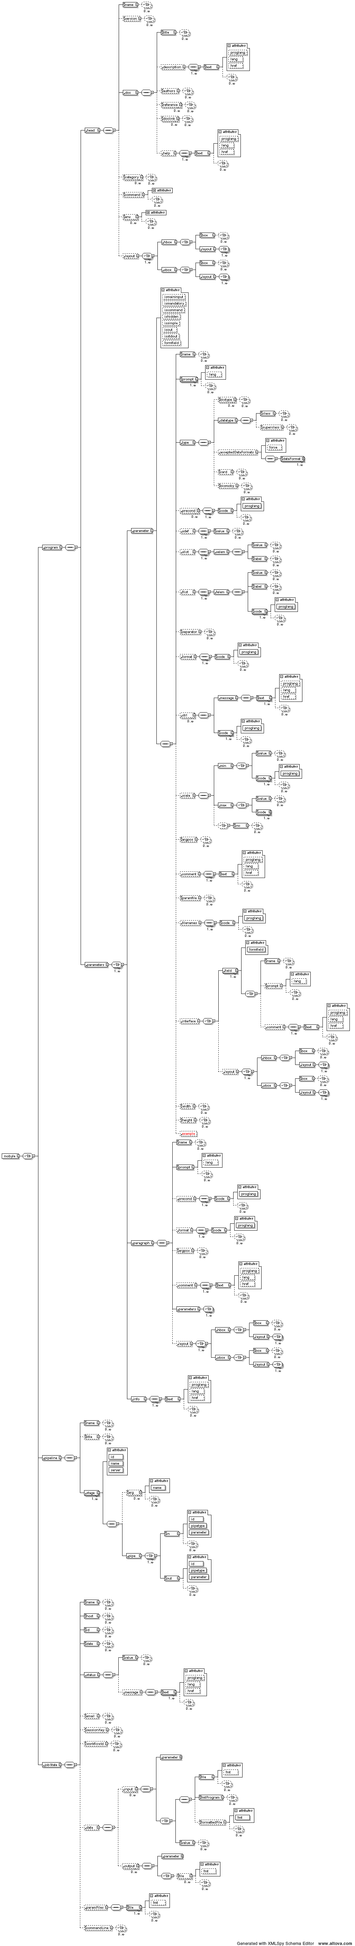 62
64

Introduction
Creating new tools to be integrated within CIPRES requires understanding the underlying XML representation. For the current implementation of CIPRES, we use Pise XML and its DTD as the framework for deploying tools. This document is verbose, and is intended as a source reference for all aspects of the XML.

Our first recommendation is that you build your PiseXML file from an existing one. Two we have created that are good are beast_tg.xml and raxmlHPC8_xsede.xml.

We describe here the different elements and attributes of the Pise DTD and their use within CIPRES. We have tried to keep the DTD of Pise as standard for CIPRES Tools. However, the CIPRES application handles the Pise XML file, and uses it to generate the command line in a very different way than Pise/Mobyle applications. Therefore, while the XML specifications are nearly identical, the different philosophies of the two applications introduce some meaningful changes in which elements are used. The document started from the basic description of these elements from Pise and noted changes in use and description in RED text, and particularly significant changes are noted in red boxes.
One change to Pise XML introduced by the CIPRES application: the attribute isinput=1 was added to indicate that the parameter in question is the main input of the tool.

There is also a significant change in use of the <filenames> element. The element is generally used within Pise to permit users to specify output file names. User specification of file names is not supported in CIPRES currently, and the <filenames> element is used to name output files explicitly in Pise XML files used by CIPRES.

Not all attributes and elements in Pise are used in CIPRES, and this is articulated in the Tables and Text below (Sections 2.3.3, 2.3.4., and 2.3.7).

Finally, the options in Perl scripting are much more restricted in CIPRES than in Pise. The Perl set of options available in CIPRES are described in Section 2.4

Please see Pise Code Generation under SVN for description of command line generation from Pise XML within CIPRES.

The complete Pise DTD is placed in Appendix B below. The Pise specification was replaced in early 2008 by the Mobyle specification at the Pasteur Institute. In Appendix C below we provide the DTD for Mobyle as of 4/2008.

Pise XML documents for a CIPRES tool should start with:

<?xml version="1.0" encoding="ISO-8859-1" ?>
<!DOCTYPE pise SYSTEM "http://www.phylo.org/dev/rami/PARSER/pise.dtd">

<pise>
...
<!—- To include all the elements-->
...
</pise>

Taking advantage of XML to avoid rewriting code.

A general benefit of using XML is that frequently repeated code bits can be called into any number of working files using ENTITY statements.

For example, a limited number of databases are called repeatedly, so one can save time by creating a set of XML files that contain these addresses (for example, where the BlastDB is located) and just call the XML document containing that information from inside the Tool XML document.

If a DB is needed, the address is put in using an Entity statement after

<!DOCTYPE pise SYSTEM "http://www.phylo.org/dev/rami/PARSER/pise2.dtd">

and before

<pise>

The address specifies an XML document that is imported into the working document automatically, and provides the command string that can be used to import the file.

An example of the format for declaring the addresses for XML documents is here (edited from tblastx.xml) is below; examples of files that provide DB addresses are presented in Appendix A.

Example 1.

[<!ENTITY blastDBpath SYSTEM "http://www.phylo.org/dev/rami/XMLDIR/blastDBpath.xml">
<!ENTITY nucdbs SYSTEM "http://www.phylo.org/dev/rami/XMLDIR/nucdbs.xml">]

Entities defined in this way are called into the XML file using the &addressname; statement as shown in this snippet from the TBLASTX file:

<parameter ismandatory="1" issimple="1" type="Excl">
<name>nucleotid_db</name>
<attributes>
<prompt>nucleotid db</prompt>
<format>
<language>perl</language>
&blastDBpath;
</format>
<vdef><value>GBMAM</value></vdef>
<group>3</group>
&nucdbs;

<comment>
<value>choose a nucleotide db for blastn, tblastn or tblastx</value>
</comment>
<precond>
<language>perl</language>
<code>$blast2 =~ /^blastn|tblast[nx]$/</code>
</precond>
</attributes>
</parameter>

In this example, the string “&blastDBpath;” calls the XML document at "http://www.phylo.org/dev/rami/XMLDIR/blastDBpath.xml" that specifies the location of the blastdb. The &nucdbs; statement calls "http://www.phylo.org/dev/rami/XMLDIR/nucdbs.xml”, an XML document with a <vlist> statement that provides a dropdown of appropriate nucleic acid databases (see Appendix A). This way one need not re-write (and risk error) for each new tool that calls these addresses.

Pise XML description

The top level of the PiseXML dtd consists of a <head element>, a <command> element, and a <parameter> element (Figure 1).

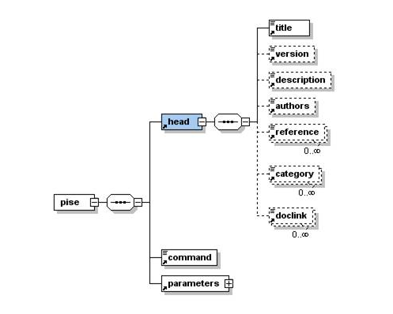

Figure 1. <head> element, PiseXML dtd

<head> element

Element:< head>
Sub-elements: <title>; <version>; <description>; <authors>; <reference>; <category>; <doclink>
Source: consense.xml

Sub-elements:

<title> is a string. It gives a short title for the tool. One such Element only. Required.

<version> is a string. It gives the current version of the tool. One such Element only. Required for CIPRES. In CIPRES, if a tool is part of a package, like EMBOSS or Phylip, the convention is to include the package name prior to the version number in this element.

<description> is a short description. In Pise, the text is published on the web page
In CIPRES, it is also published on the tool selection page
Required for CIPRES.

<authors> is a string. Lists the tool authors. One such element only. (Optional)

<reference> is a string. Lists any publications describing the tool. There is no limit on the number of these elements. (Optional)

<category> is a string. More than one permitted. There is currently no restriction on the values allowed here.
Lists the tool type, will be used as a controlled vocabulary in the future for CIPRES. Required for CIPRES.

<doclink> is a string. This is a hyperlink referring to a document that explains the tool. More than one is permitted. In the future this will be published on the CIPRES tool selection pages.

In CIPRES, the strings <title> and <version> are combined to create a hyperlink in the tool selection page. Clicking this hyperlink sets the tool to a task.

Example 2.

In a working file (consense.xml), the <head> element looks like this:

<head>
<title>Consense (Phylip)</title>
<version>3.6a2</version>
<description>Find A Consensus Tree</description>
<authors>Felsenstein</authors>
<reference>Felsenstein, J. 2007. PHYLIP -- Phylogeny Inference Package (Version 3.682). Distributed by the author. Department of Genetics, University of Washington, Seattle.</reference>
<reference>Felsenstein, J. 1989. PHYLIP -- Phylogeny Inference Package (Version 3.2). Cladistics 5: 164-166.</reference>
<category>Phylogeny / Alignment</category>
<doclink>http://bioweb.pasteur.fr/docs/gensoft-evol.html#PHYLIP</doclink>
</head>

<command> element

Element: command
Sub-elements: None
Source: bl2seq.xml

<command>blast2</command>

<command> Is used differently in Pise and CIPRES. In Pise it is serves two purposes.

- It is inserted into the command line string as the invocation of the executable to initiate a run. The default <group> for this parameter = 0 (see below).

- It is used as the unique identifier for artifacts that belong to this program. Files relating to this interface will be named with this string.

For example, the <command>clustalw</command> causes the Unix command line string to be delivered starting with the string: "clustalw". The related artifacts clustalw.html, clustalw-simple.html clustalw.pl, etc will be named using the <command> string value.
In CIPRES:

The command string is not supplied from the <command> element value. It is instead defined explicitly as a hidden parameter, with <group>=”0”this will be described in Section below.

In CIPRES, code generation (JSP, Java, etc.) requires that the name of the file “XYZ.xml” be identical to the value given in <command>.

<command>XYZ</command> = XYZ.xml

The command function has no role in CIPRES beyond that.

In Pise XML, you can also define <command> using the iscommand=”1” Boolean attribute of parameter (see below). This is not used in CIPRES.

In CIPRES, <command> is not associated with a group, since it is not used to construct the Unix command line. (Tool xml developers don’t necessarily need to be aware of this, but the <command> is used by swami as the filename for generated jsp pages and as the name of generated java classes. ) The <command> value should be identical to the filename of the tool xml file and should be all lowercase.

Parameter Definition
Once the command element is given, the parameters of the file are defined.

The <parameter> element
There is one definition for every "parameter" of the tool, and the definition uses the <parameter> element. Any parameter in PiseXML is opened with the <parameter> tag.

The <parameter> element must have a type attribute (type= Section 2.3.4) and it has either implied or explicit “Boolean” attributes (isattribute= Section 2.3.5).

In addition to these attributes, a <parameter> element has the sub-elements <name>, <attributes>, and (optionally) <paragraph> (Figure 2).

BEWARE: There is a semantically unfortunate construction here:

- any <parameter> element can have one or many attributes. These are proper XML attributes inside the <parameter> tag (see Figure 1). The <parameter> element attributes are described in detail in Sections 2.3.5 and 2.3.6.

- <parameter> elements also have sub-elements with the unfortunate name <attributes>. The <attributes> element encloses all of the information about a parameter and its execution in the interface.

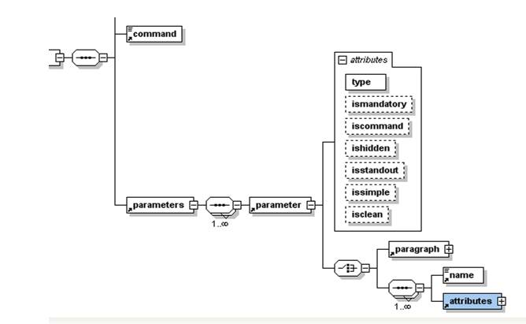
Figure 2. Elements and Attributes of the <parameter> element.

<name> Value = string. Provides a convenient handle to refer to the parameter. (Required)

<attributes> Value=n/a. The <attributes> element contains a variety of sub-elements that completely describe the command line elements to be created, as well as how these elements are to appear in the interface. (Required)
<paragraph> Value=n/a. The <paragraph> element is used when is important to organize a group of parameters in an explicit way, and to describe the grouping in more detail, both through text and organization. Use of this element is important for displaying the interface, however, use of its sub-elements can be complex, and can cause problems in CIPRES. (See Section 2.3.7).
Example 3.

Here is an example of parameter specification:

<!ELEMENT parameter (paragraph|(name, attributes)+)>
<!ATTLIST parameter type (InFile|Sequence|OutFile|Results|Switch|Excl|List|Integer|Float|String|Paragraph|Label) #REQUIRED

ismandatory %boolean; #IMPLIED
ishidden %boolean; #IMPLIED
issimple %boolean; #IMPLIED
isinput %boolean; #REQUIRED (CIPRES Only)
iscommand %boolean; #IMPLIED
isclean %boolean; #IMPLIED
isstandout %boolean; #IMPLIED>

The attributes in red are in Pise, but are not relevant in CIPRES.
In CIPRES, the Boolean attribute isinput=“1” was introduced to identify the main input for a file.

Boolean attributes for <parameter> element.

Boolean parameters are included within the <parameter> element as follows:

<parameter issimple=”1” type="Paragraph">

The allowed values for each Boolean is 1 or 0. However, they default to 0 and are typically omitted if the statement is false. A parameter can have zero or many Boolean attributes.

In CIPRES, only the attributes ismandatory=”1”; issimple=”1”, and ishidden=”1”; isinput=”1” are used.

.

Allowed Values for Booleans are:

‘ismandatory’ | Indicates a required parameter
‘ishidden' | Parameter is not visible in the user interface
‘issimple’ | Specifies a parameter to be included in the simple form.
‘isinput’ | CIPRES: This parameter is used to indicate the principal input of a particular tool.

Parameter options:
ismandatory: when this is set to 1, the red asterisk appears in the browser interface, indicating that a value is required for submission. This option also alters the behavior of multiple selection boxes. When the value is set to 0, a blank option appears in the dropdown, allowing the user to specify no value for this parameter.

ishidden: when this is set to 1, the parameter does not appear in the interface. Rather, a string or other value can be delivered over which the user has no control. This option is used, for example, to deliver information to the scheduler, when the user is not allowed to control the information, rather such values are determined by the developers based on benchmarking studies. See Section 2.3.10. Thus information can also be used to create auxiliary files for the scheduler. Although it is not a requirement, typically hidden parameters that control configuration and return results are placed at the top of the XML document, while those that specify visible parameters in the interface appear after configuration and results parameters.

issimple: when this is set to 1, the option appears at the top of the web form, under “simple parameters.” When it is set to 0, the parameter will appear in the interface under “advanced options.” See Section 2.3.3.

isinput: only one parameter may declare this attribute. It is used to flag the “primary” input to the tool. The primary input is handled differently from other inputs in that it is selected outside of the tool’s parameter configuration gui, and may in the future be used by CIPRES to match certain types of data with the tools that can accept that data type as input. It is the case that sometimes a tool has more than one input. As things stand, we must simply choose one of these as the main input, and request the others in the parameter gui.

Making simple and complex forms

In CIPRES, the Pise XML issimple attribute influences display of parameters on the parameters page. Simple parameters should always be identified in a Pise XML file. They will appear at the top of the form, independent of their location within the page. So simple parameters within Paragraphs will simply be displayed in the order in which they appear in the XML document, at the top of the page, independent of the surrounding environment. A simple parameter is specified like this:

<parameter ismandatory="1" issimple="1" type="Sequence">
By default, issimple=”0” . In that situation, paragraphs are respected.

Type attributes for the <parameter> element

One and only one type attribute is required for to define each parameter. Allowed values for type= are as follows:

'InFile' | Input file used for any input.
‘Sequence' | Pise: Input file of protein or nucleic acid sequences.  CIPRES: ‘Sequence’ Input files are not distinguished from ‘InFile’ types.
‘Input’ | In CIPRES, the Boolean attribute isinput=“1” was introduced to identify the main input for a file. Not used in Pise
'OutFile' | Pise: All output files, but typically for direct text output.
'Results' | Pise: output files (not real "parameters" known by the user)  CIPRES: type=‘OutFile’ output is not distinguished from type=‘Results’; however the two behave slightly differently
'Switch' | “yes or no” option
'Excl' | single choice list
'List' | multiple choice list
'Integer' | an integer value
'String' | a string (without space and special  characters)
'Paragraph' | a list of grouped parameters
‘Float’ | a float value
In Pise: a value can be also be a list:
{ <strings> } (comment)
where <strings> is a list of strings between ""
or: { <integers> } (seqfmt)

some lists have a special format, with two elements for each item: a "key" and a "text" (format, precond, vlist, flist)

{ key string }

as well as this kind of lists (ctrl):
{ key1 { key2 string } }

In CIPRES we avoided using this type of description; it’s not used frequently, so we did not feel that adding the complexity required was justified.

Examples: parameter attributes in code and appearance

Attribute: ‘InFile’
How it looks in the interface: Infile creates an upload box that accepts input from the current folder.

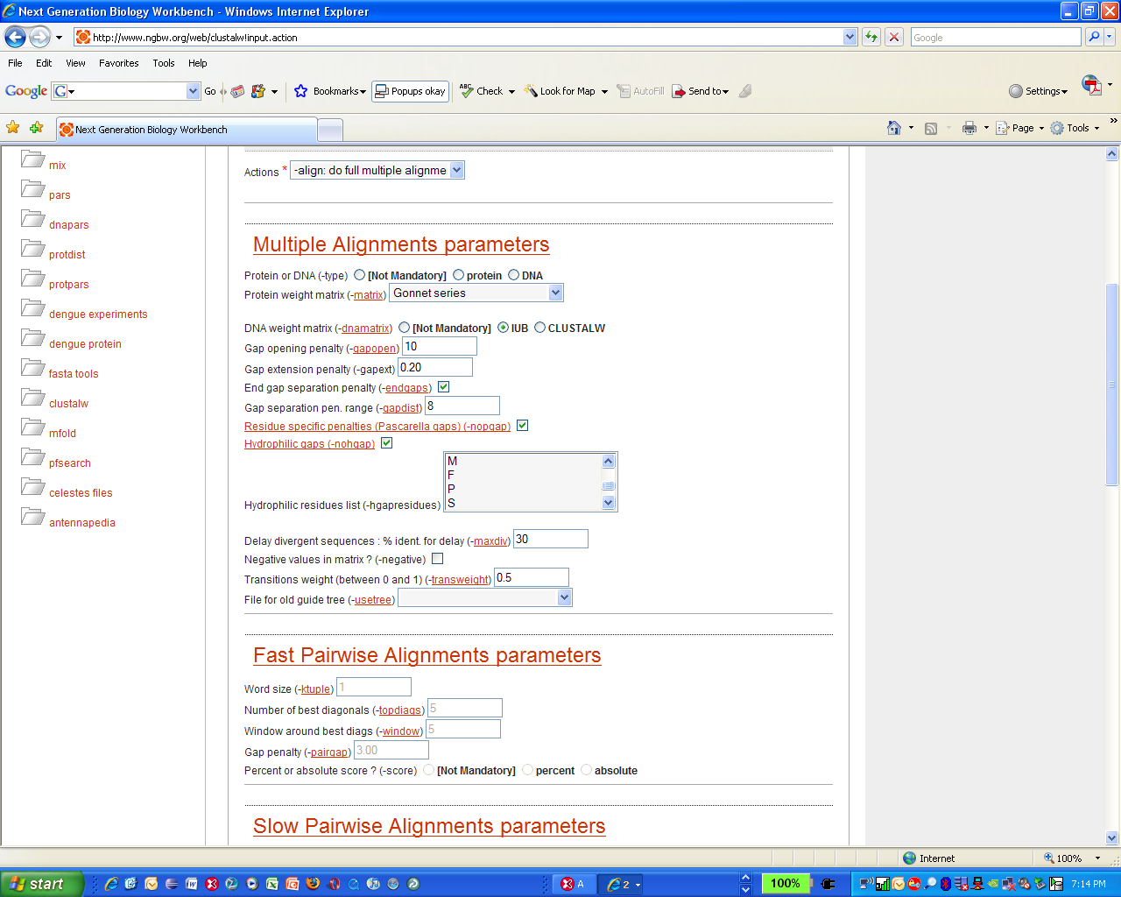

How it looks in code:

<parameter type="InFile">
<name>usetree</name>
<attributes>
<prompt>File for old guide tree (-usetree)</prompt>
<format>
<language>perl</language>
<!-- <code> ($value)?" -usetree=$value":""</code> -->
<code> " -usetree=usetree.dnd"</code>
</format>
<group>2</group>
<comment>
<value>You can give a previously computed tree (.dnd file) - on the same data</value>
</comment>
<precond>
<language>perl</language>
<code>($actions =~ /align/ )</code>
</precond>
</parameter>

Attribute: ‘Sequence’
How it looks in the interface: Sequence is identical to Infile.

Attribute: ‘Outfile’

Results can be returned either by <parameter> elements with Outfile or Results attributes.

How it looks in the interface: There is no consequence of this parameter in the interface.

How it looks in code:

<parameter type="OutFile" ismandatory="0" issimple="0" ishidden="0">
<name>outseq</name>
<attributes>
<prompt>outseq -- stopprotein (-outseq)</prompt>
<format>
<language>perl</language>
<code> " -outseq=outseq.out"</code>
</format>
<group>7</group>
<comment>
<value>Provide ORF sequence output</value>
</comment>
<filenames>outseq.out</filenames>
<pipe>
<pipetype>seqsfile</pipetype>
<language>perl</language>
<code>1</code>
</pipe>
</attributes>
</parameter>

There does not seem to be much consistency in the use of attributes for type=OutFile. Specifically, ismandatory, ishidden, and issimple modifiers are set “0” n the example above, but they are set to “1.” One difference between Outfile and Results type attributes is that for Outfile, <group> designations are used often (see emboss files), these are not used for type=Results attributes. It is not clear what consequence this might have.

Attribute: ‘Results’
How it looks in the interface: There is no consequence of this parameter attribute in the parameter interface.

How it looks in code:

This example is from muscle.xml
<parameter ishidden="1" type="Results">
<name>phylip_output_interleaved</name>
<attributes>
<precond>
<language>perl</language>
<code>$output_phyi</code>
</precond>
<filenames>outputi.phy</filenames>
</attributes>
</parameter>

WARNING: In CIPRES, inclusion of a Comment in a “Results” parameter will crash the system. The message will be cryptic.
Here’s a little trick Terri taught me that lets you gather all the output from a tool while you are developing, when using CIPRES:

<parameter ismandatory="1" ishidden="1" type="Results">
<name>allout</name>
<attributes>
<filenames>*</filenames>
</attributes>
</parameter>

By inserting this, you can return all the results files, and troubleshoot other results returning tools. Just comment it out when you are done.

There does not seem to be much consistency in the use of “is” attributes for the Parameter attribute type=“Results”. Specifically, ismandatory, ishidden, and issimple modifiers are set “1” or absent in various examples. However, setting the modifier to issimple=”0” seems to fail in the example above. One difference between Outfile and Results elements is that Outfile elements often contain <group> designations, these are not used with Results elements. It is not clear what consequence this might have.

Attribute: ‘Switch’
How it looks in the interface: Switch allows only true/false options.

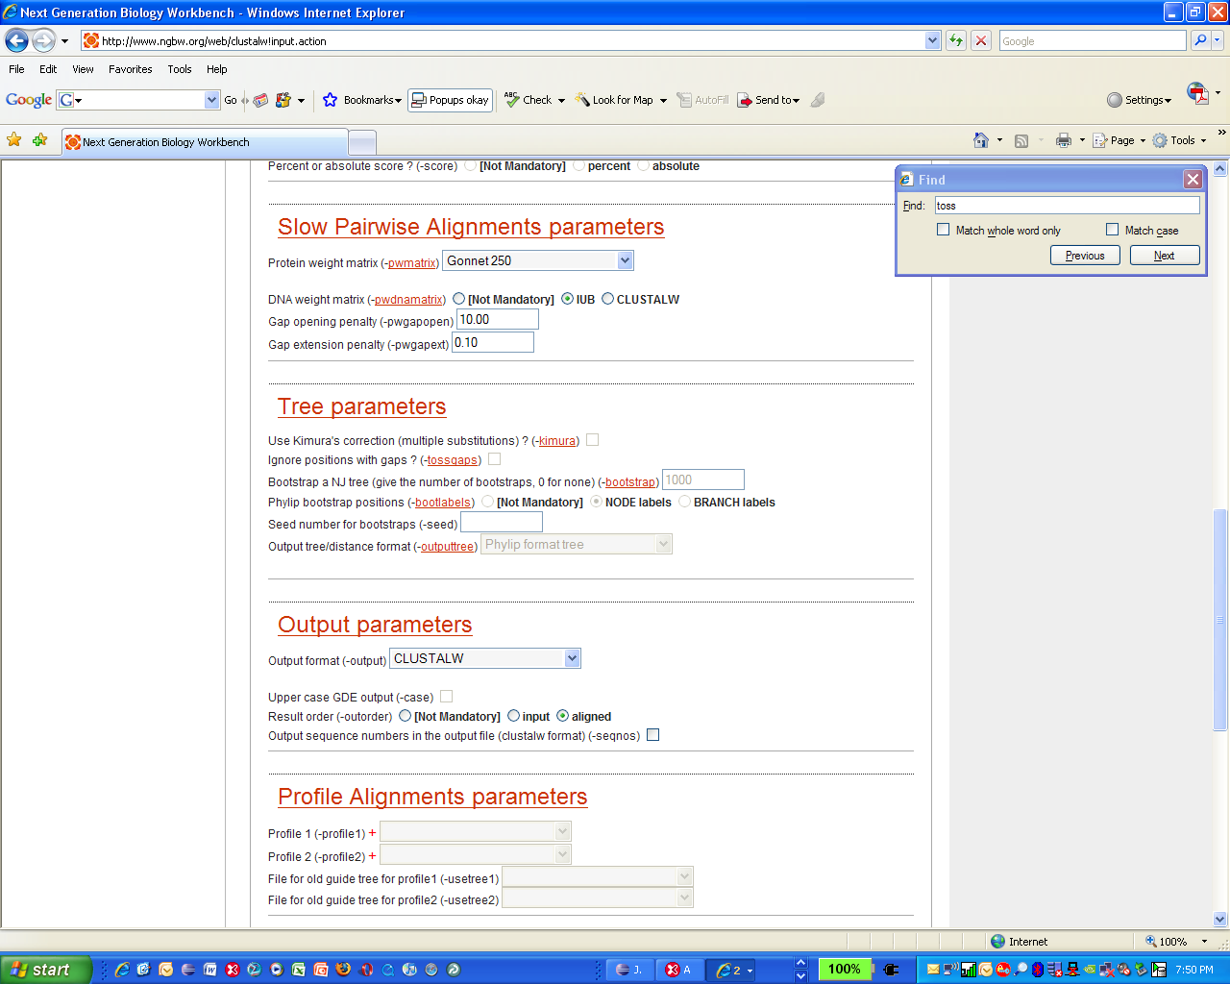

How it looks in code:
<parameter type="Switch">
<name>tossgaps</name>
<attributes>

<prompt>Ignore positions with gaps ? (-tossgaps)</prompt>
<format>
<language>perl</language>
<code> ($value)?" -tossgaps":""</code>
</format>
<vdef><value>0</value></vdef>
<group>2</group>
<comment>
<value>With this option, any alignment positions where ANY of the sequences have a gap will be ignored. This means that 'like' will be compared to 'like' in all distances. It also, automatically throws away the most ambiguous parts of the alignment, which are concentrated around gaps (usually). The disadvantage is that you may throw away much of the data if there are many gaps. </value>
</comment>
<precond>
<language>perl</language>
<code> ($actions =~ /tree/) </code>
</precond>

</attributes>
</parameter>

Attribute: ‘Excl’

Tips for ‘Excl’ lists:
- Use Excl instead of a Switch if you want the two values to be something other than true or false.
- If “excl” issimple=”0” you will has three items or less in the <vlist> , the gui will display it as radio buttons.

- Whenever ismandatory=”0” the gui will add a third radio button entitled "Not Mandatory" that sets the value to "" (see below)

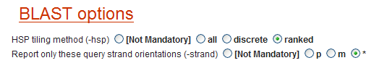

- if there are more than three items in the <vlist>, you'll get a drop down list. If ismandatory=”0” the gui will add an additional blank choice that sends "",

How it looks in the interface:

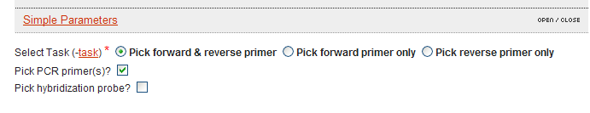

<parameter type="Excl" ismandatory="1" issimple="1" ishidden="0">
<name>task</name>
<attributes>
<prompt>Select Task (-task)</prompt>
<vlist>

<value>1</value>
<!-- CIPRES -->
<label>Pick forward &amp; reverse primer</label>
<!-- -->
<value>2</value>
<label>Pick forward primer only</label>
<value>3</value>
<label>Pick reverse primer only</label>
<!-- cipres
<value>4</value>
<label>No Primers needed</label> -->
s </vlist>
<vdef>
<value>1</value>
</vdef>
<format>
<language>perl</language>
<code>" -task=$value"</code>
</format>
<group>4</group>
<!-- CIPRES-->
<precond>
<language>perl</language>
<code>$noprimer</code>
</precond>
<!-- -->
</attributes>
</parameter>
If a parameter more than three choices are given, Excl produces a dropdown box. Only one value may be selected.

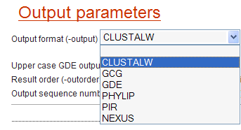
How it Looks in Code:

<parameter type="Excl">
<name>output</name>
<attributes>
<prompt>Output format (-output)</prompt>
<format>
<language>perl</language>
<code> ($value) ?" -output=$value":""</code>
</format>
<vdef><value>""</value></vdef>
<group>2</group>
<vlist>
<value></value>
<label>CLUSTALW</label>
<value>GCG</value>
<label>GCG</label>
<value>GDE</value>
<label>GDE</label>
<value>PHYLIP</value>
<label>PHYLIP</label>
<value>PIR</value>
<label>PIR</label>
<value>NEXUS</value>
<label>NEXUS</label>
</vlist>
</attributes>
</parameter>

Attribute: ‘List’
How it looks in the interface: An entire list is exposed on a dropdown box.
Default values are not displayed as highlighted. Using the ctrl button, many choices can be selected.

How it looks in code:

<parameter type="List">
<name>hgapresidues</name>
<attributes>
<prompt>Hydrophilic residues list (-hgapresidues)</prompt>
<format>
<language>perl</language>
<code> ($value &amp;&amp; ($value ne $vdef))?" -hgapresidues=\"$value\"":""</code>
</format>
<vdef>
<value>G</value>
<value>P</value>
<value>S</value>
<value>N</value>
<value>D</value>
<value>Q</value>
<value>E</value>
<value>K</value>
<value>R</value>
</vdef>
<group>2</group>
<vlist>
<value>A</value>
<label>A</label>
<value>R</value>
<label>R</label>
<value>N</value>
<label>N</label>
<value>D</value>
<label>D</label>
<value>C</value>
…..truncated…..
<label>W</label>
<value>Y</value>
<label>Y</label>
<value>V</value>
<label>V</label>
</vlist>

Attribute: ‘Integer’
How it looks in the interface: This attribute opens a box in which a value can be entered.
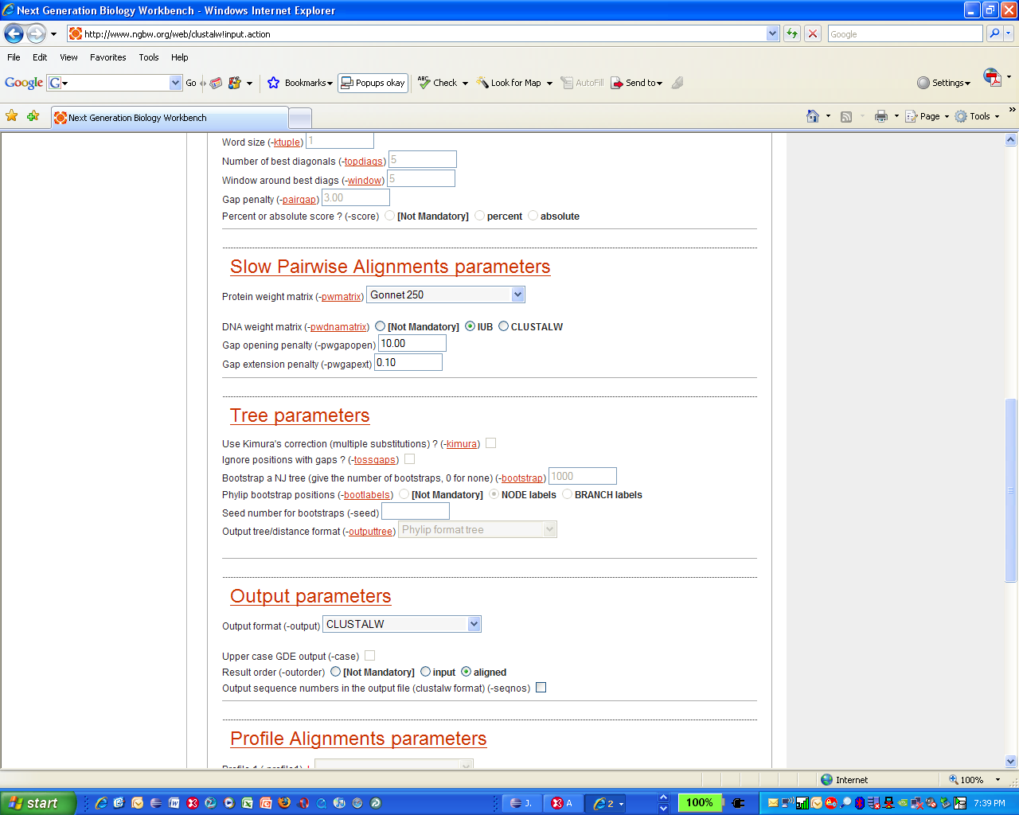

How it Looks in Code:

<parameter type="Integer">
<name>bootstrap</name>
<attributes>

<prompt>Bootstrap a NJ tree (give the number of bootstraps, 0 for none) (-bootstrap)</prompt>
<format>
<language>perl</language>
<code> ($value &gt; 0 &amp;&amp; $value != $vdef)? " -bootstrap=$value":"" </code>
</format>
<vdef><value>1000</value></vdef>
<group>2</group>
<comment>
<value>BOOTSTRAPPING is a …truncated
…the documentation for details.</value>
</comment>
<precond>
<language>perl</language>
<code> ($actions =~ /tree/) </code>
</precond>

</attributes>
</parameter>

Attribute: ‘string’
How it looks in the interface:

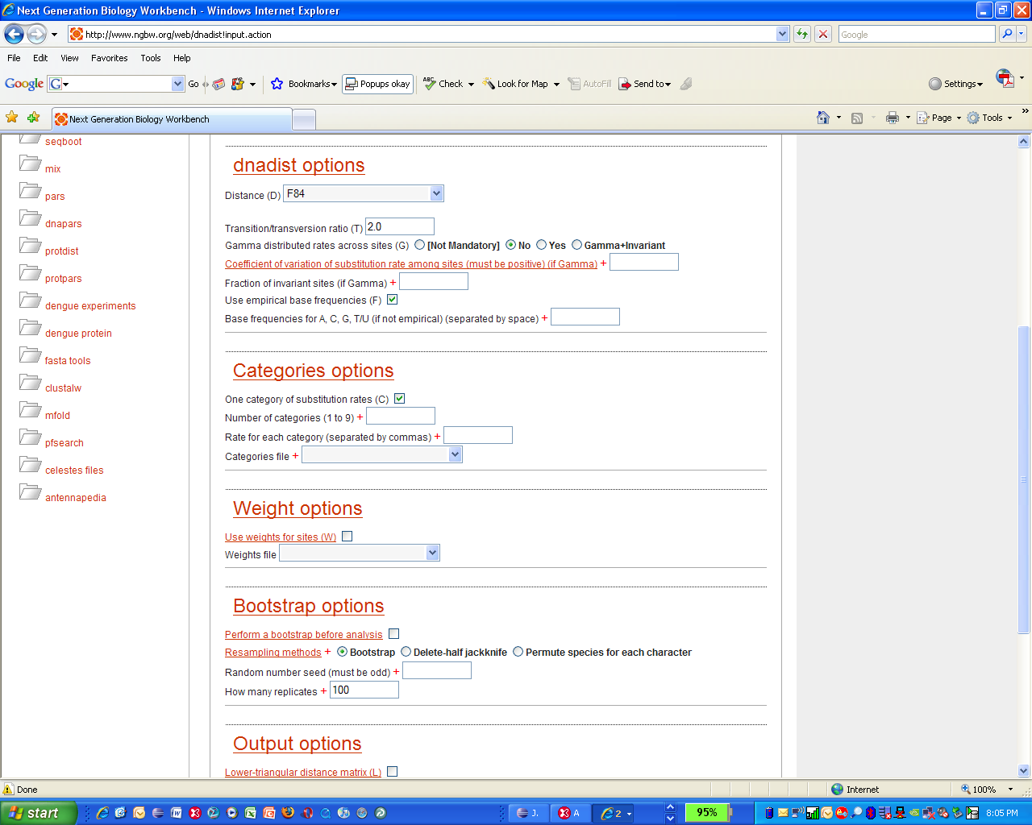

How it looks in code:
<parameter ismandatory="1" type="String">
<name>base_frequencies</name>
<attributes>

<prompt>Base frequencies for A, C, G, T/U (if not empirical) (separated by space)</prompt>
<format>
<language>perl</language>
<!-- Corrected for CIPRES-->
<!-- <code>""</code>-->
<code>($base_frequencies)? "" : "F\\n$base_frequencies\\n"</code>
<!---->
</format>
<group>2</group>
<ctrls>
<ctrl>
<message>Please check your base_frequencies entry, values should be separated by space</message>
<language>perl</language>
<code>($base_frequencies =~ s/,/ /g ) &amp;&amp; 0</code>
</ctrl>
</ctrls>
<precond>
<language>perl</language>
<code>! $empirical_frequencies</code>
</precond>
<paramfile>params</paramfile>
</attributes>
</parameter>

Attribute: ‘Paragraph’
How it looks in the interface:
This attribute organizes the parameters on the generated page.

How it looks in code: (See Section 1.4.7.)

Attribute: ‘Float’
How it looks in the interface: This attribute opens a box in which a floating point value can be entered.

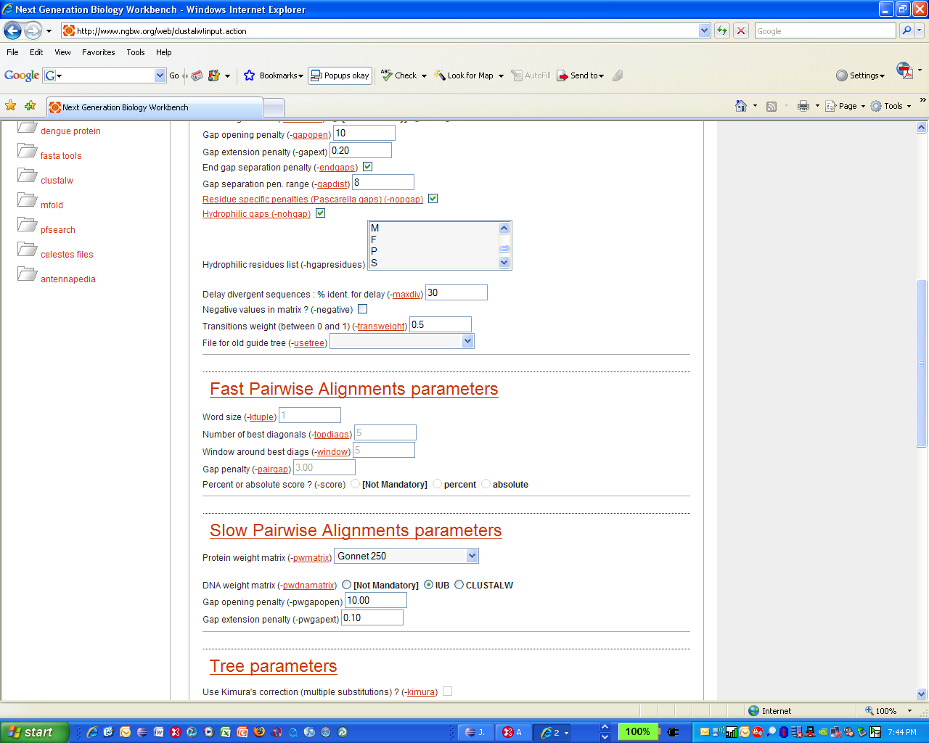

How it looks in code:

<parameter type="Float">
<name>pairgap</name>
<attributes>
<prompt>Gap penalty (-pairgap)</prompt>
<format>
<language>perl</language>
<code> (defined $value &amp;&amp; $value ne $vdef)?" -pairgap=$value":""</code>
</format>
<!--<vdef><value>3</value></vdef> -->
<vdef><value>3.00</value></vdef>
<group>2</group>
<comment>
<value>This is a penalty for each gap in the fast alignments. It has little affect on the speed or sensitivity except for extreme values.</value>
</comment>
<precond>
<language>perl</language>
<code>($quicktree eq "fast") &amp;&amp; ($quicktree eq "fast")</code>
</precond>

Parameter organization.
As some programs have many parameters, Pise XML provides two levels of organization for parameters: the <parameters> and <paragraph> elements.

<parameters> Multiple lists of parameters can be encased in the <parameters> element. There can be multiple <parameters> elements throughout the file.
<paragraph> The paragraph element is used when is important to organize a group of parameters in an explicit way, and to describe the grouping in more detail, both through text and organization.
Example 4. A Single Parameter

<parameter issimple=”1” type="Paragraph">
<paragraph>
<name>filter_opt</name>
<prompt>Filtering and masking options</prompt>
<group>4</group>
<comment>
<value>Blah blah blah.</value>
</comment>
</paragraph>
</parameter>

In this example, the Boolean issimple=”1” specifies that the parameter will be displayed at top of the page;

type="Paragraph" defines the <parameter> as a “paragraph”. When type=”paragraph” the element <paragraph> must appear within the <parameter> element.

Example 5. Single Parameter with several attributes:

<parameter type="Switch">
<name>filter</name>
<attributes>
<prompt>Filter query sequence (DUST with blastn, SEG with others) (-F)</prompt>
<format>
<language>perl</language>
<code>($value) ? "" : " -F F"</code>
</format>
<vdef><value>1</value></vdef>
<group>4</group>
</attributes>

This example shows a <parameter> that is not in a <paragraph>, but has many <attributes> The <prompt> value will be printed at the point where the parameter is entered in the resulting web page, but will not be exposed in the Help section at the bottom of the page.

The <paragraph> element
Value(s): n/a
Sub-elements: <name>; <prompt>; <precond>; <group>; <format>; <comment>; <parameters:
Source: clustalw.xml
Use Case: The paragraph element is used to organize the output and explanatory notes for display purposes.

Example 6.

<parameters>
<paragraph>
<name>fastpw</name>
<prompt>Fast Pairwise Alignments parameters</prompt>
<precond>
<language>perl</language>
<code>($quicktree eq "fast")</code>
</precond>
<group>2</group>
<comment>
<value>These are for similarity scores calculation</value>
</comment>
</paragraph>
</parameters>

The order of this list is significant, because it determines the order of the paragraph in the HTML form produced, and the order in the help section at the bottom of the page..

Text from the <prompt> element will appear in the web page above these parameters, and as a major heading in the help file at the bottom of the page. The <comment><value> elements included in a paragraph are displayed under the major heading in the help section at the bottom of the page. The order of the items in the help page is determined by the order of the paragraphs.

The <paragraph> element allows the use of several sub-elements that have functions and names similar to those for the <attributes> element. (Figure 3). This can cause confusion, so use these with care.

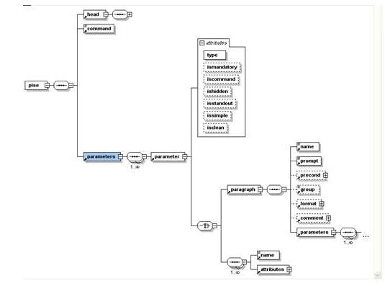
Figure 3. Sub-elements of the Paragraph element.

<name> Value = string. Provides a convenient handle to refer to the parameter. (Required).

<prompt> Value = string. (same as use under <attributes> element, see Section 2.3.9.5). Terse information about the subset of parameters contained inside the <paragraph>. This information is published above all of the parameter entry forms for this paragraph in the web interface, and also is used to create a subject header in the help section of the interface.

<parameters> Value=n/a. This is just an organizing grouping element for all parameters in a paragraph.

<comment> Value=n/a. Sub-elements: <value> (same as under <attributes> see Section 2.3.9.6. When set under paragraph, this element creates text that is inserted at the bottom of the page, under the heading generated by the <prompt> element. The comment text is a string that appears in the <value> tag, which is the sub-element of <comment>.

Use of the paragraph sub-elements <precond>, <group>, and <format> can provide another level of flexibility for developers, but it can also be problematic for command line rendering in CIPRES. For this reason, we recommend that developers creating Pise XML files for CIPRES set these elements for each individual parameter, rather than setting them for the entire paragraph element.
<format> Value: n/a. Sub-elements: <language>; <code>
<format> is used to indicate a line of code that will transform the input value into the correct syntax for the command line parameter. When used in a <paragraph> element, the statement is applied to all of the parameters in the paragraph. Inside the <format> element one must place code, language, and other element information to permit the desired conversion.

<precond> Value = n/a. Sub-elements: <code>; <language>. This element is basically the same as format, except that it's used in a test;

example: '! $bootstrap' will be used as:
if (! $bootstrap) which means:

“the pre-condition for taking this parameter into account is that the bootstrap parameter is not set.” When used in <paragraph> the precondition is applied to all of the parameters within the paragraph.

<group> Value=integer. When set under paragraph, it means that every parameter generated within the paragraph tag is submitted as a bolus in the third position of the command line. It means the order cannot be set with greater refinement, and so the tool must not care about the order of any parameters that are set here.
Warning: It is not clear what would happen if <format>, <precond> or <group> was set under paragraph, and under the individual parameter, if these values were in conflict. Rules for precedence are unknown

Sub-values for the <attributes> element

There are many sub-elements that are allowed under the <attributes> element. Some have sub-elements that contain code, and some are restricted to string or integer values only. These are listed below, followed by an example of the use of each attribute.

'prompt' | provides text presented to the user to help in selection of the parameter
'comment' | places text explaining the parameter in the user interface and in the help section
'group' | specifies the position of this parameter in the Unix command line or into the file if the parameter is going to write into a file instead.
'size' | for presentation tools (this is rarely used; 3 files only, the mview docs and drawtree.xml)
'separator’ | describes the separation values for a List. Only used in one file, current file: tacg.xml
'paramfile' | assemble several parameters into a file
'filenames' | CIPRES: does not allow users to enter <name> (in contrast to PISE). To compensate, CIPRES uses ‘filenames’ to provide explicit names for all files that are required; a line is added for each such file in the PISE pages to provide a default name.  In contrast to PISE, this statement is required in CIPRES whenever  type= Infile, Sequence, Results, OutFile  For type= Infile , Sequence  it must be an explicit file name <name>.<extension>  Example:  <filenames>boxshade.matrix</filenames>  For type=Results, OutFile  it can supply a wildcard with only the extension for the output files; or just use a wildcard * to return all files.  Example:  <filenames> *.result *.pict </filenames>
'format' | (code to transform the input value into a correct Unix syntax for the parameter)
'vdef' | specifies a default value
'vlist' | specifies a list of values to select from
'flist' | used in conjunction with vlist, to provide individual code statements instead of text strings for each selected value
'precond' | a pre-condition of the parameter
'ctrls'/’ctrl | permits extra code validation/controls of the entered value
'seqfmt' | PISE: numerical designation of sequence format for readseq  CIPRES: not used
'scalemax’; ‘scalemin’ | PISE: for Integers, sets min, max, and incremental values.  CIPRES: not used
'scaleinc’ | PISE:  CIPRES: not used
'pipe’ | PISE: for Integers, sets min, max, and incremental values.  CIPRES: not used
'withpipe’ | PISE: for Integers, sets min, max, and incremental values.  CIPRES: not used

Examples: parameter sub-elements from Pise XML files

Element: <prompt>
Value: string
Sub-elements: none known
Source: degapseq.xml
Use Case: <prompt> is used to just to specify the text presented to the user on the form.
In the interface:

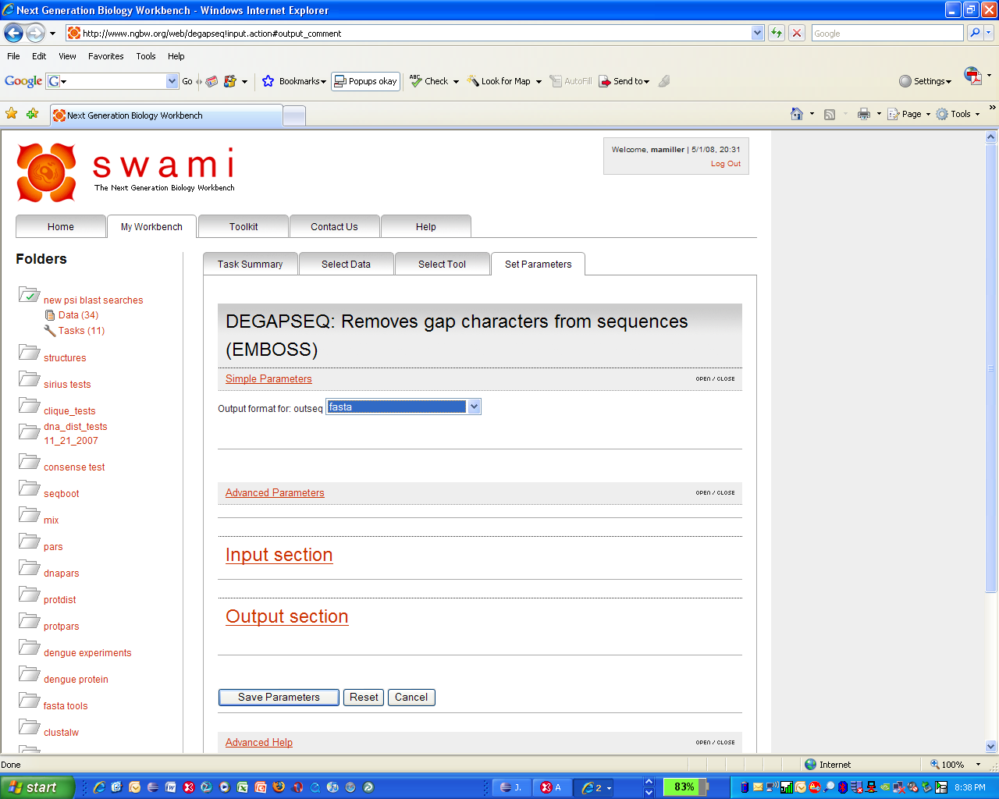

In code:
<parameter type="Excl" issimple="1">
<name>outseq_sformat</name>
<attributes>
<prompt>Output format for: outseq</prompt>
<vlist>
<value>fasta</value>
<label>fasta</label>
<value>gcg</value>
<label>gcg</label>
<value>phylip</value>
…….

Element: comment
Value: N/A
Sub-elements: <value>
Source: blastx.xml
Use Case: <comment> signifies a text block is inserted at the bottom of the page, under the heading specified by the <paragraph> command. The contents of the text block are indicated by <value> elements. More than one set of <value> elements can occur in a given <comment>.

Sub-element: value
Value(s): string
Modifies: <comment>

How it looks in the interface: The comment is written to a the help section at the bottom of the page.

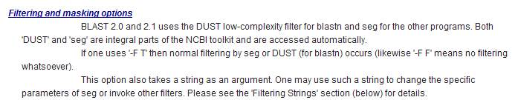

How it looks in Code:

<parameter type="Paragraph">
<paragraph>
<name>filter_opt</name>
<prompt>Filtering and masking options</prompt>
<group>4</group>
<comment>
<value>BLAST 2.0 and 2.1 uses the DUST low-complexity filter for blastn and seg for the other programs. Both 'DUST' and 'seg' are integral parts of the NCBI toolkit and are accessed automatically.</value>
<value>If one uses '-F T' then normal filtering by seg or DUST (for blastn) occurs (likewise '-F F' means no filtering whatsoever). </value>
<value>This option also takes a string as an argument. One may use such a string to change the specific parameters of seg or invoke other filters. Please see the 'Filtering Strings' section (below) for details.</value>
</comment>
<parameters>

Element: <group>
Value: integer
Sub-elements: none known
Source: clique.xml
Use Case: <group> is used to specify the order of parameters in the command line. It has no consequence in the interface.

<prompt>Input File</prompt>
<format>
<language>perl</language>
<!-- <code>"ln -sf $infile infile; "</code> -->
<code>"ln -sf infile.phylip infile; "</code>
</format>
<group>-10</group>
<comment>
<value>Example input file:</value>

In this example, the parameter specified will be inserted in the command line in the position -10. The positions are all relative, so the exact position may not be known from this value alone.
In PISE: group values are unbounded, some values are 9999, 999, etc.
In CIPRES: group values between -99 to 99 are allowed. We prefer to use
also the absolute position for the parameter in the UNIX command and not
the relative position as in PISE. (N.B: if | group value | > 99
PiseCommandRenderer will fail).

Element: <size>
Value: Integer
Sub-elements: none known.
Source: mview_blast.xml
Use Case: <size> is used to specify the size of the presentation font. It is used only 3 times in all of the PISE we have used as of 4/26/2008. It has no consequence in the interface, other than opening the entry box for an integer.

<parameter type="String">
<name>con_threshold</name>
<attributes>

<prompt>Consensus line thresholds (in range 50..100) (separated by commas) (-con_threshold)</prompt>
<format>
<language>perl</language>
<code>($value &amp;&amp; $value ne $vdef)? " -con_threshold $value":""</code>
</format>
<vdef><value>100,90,80,70</value></vdef>
<group>3</group>
<precond>
<language>perl</language>
<code>$consensus</code>
</precond>
<size>50</size>
</attributes>
</parameter>

Element: <separator>
Value: Integer
Sub-elements: none known.
Source: mview_blast.xml
Use Case: <size> is used to specify a separator, like a blank space, that must be inserted into a command line to make it work. It is used only 1 time in all of the PISE we have used as of 4/26/2008. It has no consequence in the interface.

<group>2</group>
<vlist>
<value>1</value>
<label>1</label>
<value>2</value>
<label>2</label>
<value>3</value>
<label>3</label>
<value>4</value>
<label>4</label>
<value>5</value>
<label>5</label>
<value>6</value>
<label>6</label>
</vlist>
<precond>
<language>perl</language>
<code>$orf</code>
</precond>
<separator>' '</separator>

</attributes>
</parameter>

Element: <paramfile>
Value: string:
Sub-elements: none known.
Source: boxshade.xml
Use Case: <paramfile> packages up a number of supplied parameters into a file that can be delivered on the command line. It is useful whenever the executable is expecting a complex set of instructions to be delivered in a single file with a fixed name. In the example below, the parameters are specified without user input, and delivered to the command line in the form of a file entitled “params”. This element has no consequence in the interface.

<parameter ishidden="1" type="String">
<name>input_format</name>
<attributes>
<format>
<language>perl</language>
<code>"2\\n"</code>
</format>
<group>2</group>
<paramfile>params</paramfile>
</attributes>
</parameter>

Element: <filenames>
Value: string
Sub-elements: none known.
Source: boxshade.xml
Use Case: <filenames> is used to specify the name of an output file. It can either be explicit and complete, or it can specify a variable that permits the first part of the name to be inherited from another line of code as seen in the example below. In CIPRES, filenames are always specified completely and explicitly with this parameter.

This example shows how this element can be used to make a file with a variable name in Pise work in CIPRES.

<parameter type="OutFile">
<name>seqalign_file</name>
<attributes>
<prompt>SeqAlign file (-J option must be true) (-O)</prompt>
<format>
<language>perl</language>
<code>($value)? " -O $value" : ""</code> (here the outfile name is a variable)
</format>
<group>4</group>
<comment>
<value>SeqAlign is in ASN.1 format, so that it can be read with NCBI tools (such as sequin). This allows one to view the results in different formats.</value>
</comment>
<precond>
<language>perl</language>
<code>$believe</code>
</precond>
</attributes>
</parameter>

This is the same code in CIPRES:

<parameter type="OutFile">
<name>seqalign_file</name>
<attributes>
<prompt>SeqAlign file (-J option must be true) (-O)</prompt>
<format>
<language>perl</language>
Variable outfile name is commented out,
<!-- <code>($value)? " -O $value" : ""</code> -->
It is replaced with a command that use an explicit file name
(required for CIPRES)
<code>" -O seqalign_file.asn1" </code>
</format>
<group>4</group>
<comment>
<value>SeqAlign is in ASN.1 format, so that it can be read with NCBI tools (such as sequin). This allows one to view the results in different formats.</value>
</comment>
<precond>
<language>perl</language>
<code>$believe</code>
</precond>
<!-- Added CIPRES -->
Now give the explicit file name
(required for CIPRES)
<filenames>seqalign_file.asn1</filenames>
<!-- -->
</attributes>
</parameter>

Element: <vdef>
Value(s): n/a
Sub-elements: <value>
Source: bl2seq.xml
Use Case: <vdef> is used to indicate the default value for any parameter. If a user does not expose the parameter page and make modifications, the <vdef>< value> will be submitted. This element must, of course, be modified by the <value> element. This provides the string or code snip that is added to the command line. It has no consequences in the interface, other than the fact that the value will be obvious on load of the page (except for the parameters of the “list” type).

Sub-element: <value>
Value(s): string
Modifies: <vdef>

Sub-element: <value>
Value(s): string
Modifies: <vdef>

Sub-element: <code>
Value(s): string
Modifies: <vdef>

<parameter ismandatory="1" iscommand="1" issimple="1" type="Excl">
<name>bl2seq</name>
<attributes>
<prompt>Blast program</prompt>
<format>
<language>perl</language>
<code>"bl2seq -p $value"</code>
</format>
<vdef>
<value>blastp</value>
</vdef>
<!--CIPRES: group 0 is required as the main command -->
<!-- <group>1</group> -->
<group>0</group>
<vlist>
<value>blastp</value>
<label>blastp: protein / protein</label>
<value>blastn</value>
<label>blastn: nucleotide / nucleotide</label>
<value>blastx</value>
<label>blastx: nucleotide / protein</label>
<value>tblastn</value>
<label>tblastn : protein / nucleotide</label>
</vlist>

Element: <vlist>
Value: N/A
Sub-elements: <value>; <label>
Source: bl2seq.xml
Use Case: <vlist> allows users to choose from a set of possible values that can be submitted as modifiers of a flag in the command line of the tool. They will be presented to the user in a dropdown box in the interface. The choices that are to be presented are nested within <vlist> as pairs of parameters:

Sub-element: <value>
Value(s): string
Modifies: <vlist>

<value> is the modifier that will be submitted after the flag on the command line.

Sub-element: label
Value(s): string
Modifies: <vlist>

<label> is the text presented to the user for their selection.

In the interface:
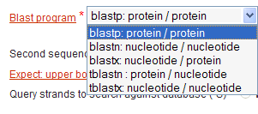

In code:

<parameter ismandatory="1" iscommand="1" issimple="1" type="Excl">
<name>bl2seq</name>
<attributes>
<prompt>Blast program</prompt>
<format>
<language>perl</language>
<code>"bl2seq -p $value"</code>
</format>
<vdef><value>blastp</value></vdef>
<!--CIPRES: group 0 is required as the main command -->
<!-- <group>1</group> -->
<group>0</group>
<vlist>
<value>blastp</value>
<label>blastp: protein / protein</label>
<value>blastn</value>
<label>blastn: nucleotide / nucleotide</label>
<value>blastx</value>
<label>blastx: nucleotide / protein</label>
<value>tblastn</value>
<label>tblastn : protein / nucleotide</label>
<value>tblastx</value>
<label>tblastx: nucleotide / nucleotide</label>
</vlist>

element: <flist>
Value: N/A
Sub-elements: <value>; <code>
Source: consense.xml
Use Case: When <vlist> is used alone, the text string specified by <value> is converted into code using the <format><code> element in its native parameter. In some cases, the use of simple text strings is not rich enough. One might need to explicitly define a line of code for each <value> provided in the <vlist>. <flist> is used to accomplish this. For each <value> specified in <vlist> the <flist> element defines a <code> element (enclosed in “”) that is inserted into the command line. Obviously, this element is always used in conjunction with <vlist>. The appearance of this parameter in the interface is indistinguishable from <vlist>.

Sub-element: <value>
Value(s): string
Modifies: <flist>

Sub-element: <code>
Value(s): a string of valid code (see Section 2.3 for more)
Modifies: <flist>

<parameter type="Excl">
<name>type</name>
<attributes>
<prompt>Consensus type</prompt>
<vlist>
<value>MRE</value>
<label>Majority rule (extended)</label>
<value>S</value>
<label>Strict</label>
<value>MR</value>
<label>Majority rule</label>
<value>ML</value>
<label>Ml (M-sub-L)</label>
</vlist>
<vdef>
<value>MRE</value>
</vdef>
<flist>
<value>MRE</value>
<code>""</code>
<value>S</value>
<code>"C\\n"</code>
<value>MR</value>
<code>"C\\nC\\n"</code>
<value>ML</value>
<code>"C\\nC\\nC\\n"</code>
</flist>

Note that the <language> element is not used for <flist>, even though it contains the <code> element.

Element: <format>
Value: N/A
Sub-elements: <language>; <code>
Source: degapseq.xml

Use Case: <format> is used to indicate a line of code that will transform the input value into the correct syntax for the command line parameter. Inside the <format> element one must place code, language, and other element information to permit the desired conversion.

Sub-element: <language>
Value(s): perl
Modifies: <format>

Sub-element: <code>
Value(s): a code string in the specified language (see Section 2.3 for more)
Modifies: <format>

In the example below, you find <language> and <code> specifiers that cause proper conversion of the entered parameter. Note that, as with <flist> the code is encased in “”. In the simple example below, the <format> statement is just delivering the command line to the tool. It has no consequences in the interface.
Note how this is a commented version, where the PISE string “” is replaced by the explicit command line for CIPRES. Note also how the group attribute has been altered to group=”0” to meet CIPRES specs.

<parameters>
<parameter ishidden="1" type="String">
<name>init</name>
<attributes>
<format>
<language>perl</language>
<!-- <code> "" </code> -->
<code> "degapseq" </code>
</format>
<!-- <group>-10</group>-->
<group>0</group>
</attributes>
</parameter>

In a more complex example, from helexturnhelix.xml, you can see the greater power of the <format> element.

<parameter type="Float" ismandatory="0" issimple="0" ishidden="0">
<name>sd</name>
<attributes>
<prompt>Standard Deviation value (-sd)</prompt>
<vdef>
<value>293.61</value>
</vdef>
<format>
<language>perl</language>
<code>(defined $value &amp;&amp; $value != $vdef)? " -sd=$value" : ""</code>
</format>
<group>3</group>
<scalemin><value>1.</value></scalemin>
<scalemax><value>10000.</value></scalemax>
</attributes>
</parameter>

In this example, the value to be submitted can be a variable, in this case $value.

Element: <precond>
Value: N/A
Sub-elements: <code>; <language>
Source: mix.xml

Sub-element: <language>
Value(s): perl (currently the only value allowed)
Modifies: <ctrl>

Sub-element: <code>
Value(s): a code string in the specified language (see Section 2.3 for more)
Modifies: <ctrl>

Use Case: The <precond> element if used the same as the <format> element (i.e it contains code to be delivered to the command line. However, it's used to establish conditionality in delivery of the command line. The <precond> element evaluates another parameter. It call the parameter using its name as a variable. In the example below (from mix.xml), the parameter use_mixed is established as a switch (yes/no). The Switch is evaluated in the <precond> statement below it, by treating $use_mixed as a variable. In the case where use_mixed=true, the parameter mixture_file is invoked, and an upload box is created. On the other hand, the parsimony_method parameter has the opposite dependency. If use_mixed=not true the parameter is disallowed.

In CIPRES, the <precond> also controls the login in the interface. When the <precond>
is activate, it opens or activates other controls in the interface.

In the interface: The left side is activated when the precondition is satisfied. The right side is inactivated.

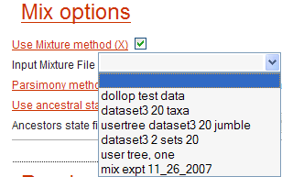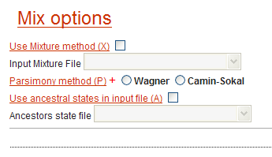

In the code:

<parameters>
<parameter type="Switch">
<name>use_mixed</name>
<attributes>
<prompt>Use Mixture method (X)</prompt>
<vdef>
<value>0</value>
</vdef>
<format>
<language>perl</language>
<code>($value)? "X\\n" : ""</code>
</format>
<group>1</group>
<paramfile>params</paramfile>
</attributes>
</parameter>

<!-- Added for new Phylip version-->
<parameter type="InFile">
<name>mixture_file</name>
<attributes>
<prompt>Input Mixture File</prompt>
<precond>
<language>perl</language>
<code>$use_mixed</code>
</precond>
<format>
<language>perl</language>
<code>""</code>
</format>
<group>-99</group>
<filenames>mixture</filenames>
</attributes>
</parameter>

<!-- -->

<parameter ismandatory="1" type="Excl">
<name>parsimony_method</name>
<attributes>
<precond>
<language>perl</language>
<code>! $use_mixed</code>
</precond>
<prompt>Parsimony method (P)</prompt>
<format>
<language>perl</language>
<code>($value eq "camin")? "P\\n" : "" </code>
</format>
<vdef><value>neighbor</value></vdef>
<group>1</group>
<vlist>
<value>wagner</value>
<label>Wagner</label>
<value>camin</value>
<label>Camin-Sokal</label>
</vlist>
<paramfile>params</paramfile>

Element: <ctrls>

Value: N/A
Sub-elements: <ctrl>
Source: blimps.xml

Sub-element: <ctrl>
Values: N/A
Modifies: <ctrls>

Sub-element: <message>
Value(s): string
Modifies: <ctrl>

Sub-element: <language>
Value(s): perl (currently the only value allowed)
Modifies: <ctrl>

Sub-element: <code>
Value(s): a code string in the specified language (see Section 2.3 for more)
Modifies: <ctrl>

Use Case: <ctrl> gives the ability to further restrict or modify input values. The role of the sub-elements is to complete the <ctrl> command. <code> and <language> are as described elsewhere.
Use a <ctrl> element to add validations, such as "must be greater than 0" or "must be
between 1 and 10".

Currently “perl” is the only language, but preserving the element allows others to be added. The <message> element creates the error message to be displayed if one of the requirements of the parameter are violated. The <ctrl> elements must be placed into one <ctrls> block.

The <ctrl> element is used here to insure the two values aren’t entered, when only one is required. In CIPRES, the <message> translates into a Javascript message.

In the Interface:

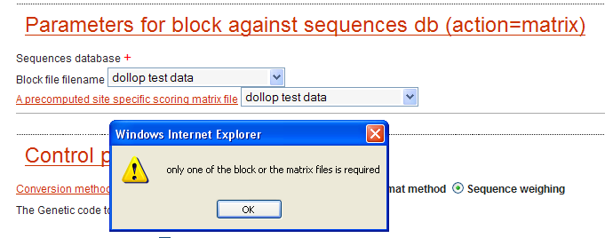

In code:
<attributes>
<prompt>Block file filename</prompt>
<format>
<language>perl</language>
<!-- ($value eq "")? "" : "BL $value\\n" </code> -->
<code> "BL block_file\\n" </code>
</format>
<!-- Added for CIPRES -->
<filenames>block_file</filenames>
<!-- -->
<group>3</group>
<ctrls>
<ctrl>
<message>only one of the block or the matrix files is required</message>
<language>perl</language>
<code>$matrix_file &amp;&amp; $block_file</code>
</ctrl>
</ctrls>
<precond>
<language>perl</language>
<code>$action eq "matrix"</code>
</precond>
<paramfile>blimps.cs</paramfile>
</attributes>

Element: <warns>

Value: N/A
Sub-elements: <warn>
Source: beast2_xsede.xml

Sub-element: <warn>
Sub-elements: <message>; <code>; <language>
Modifies: <warns>

Sub-element: <message>
Value(s): string
Modifies: <warn>

Sub-element: <language>
Value(s): perl (currently the only value allowed)
Modifies: <ctrl>

Sub-element: <code>
Value(s): a code string in the specified language (see Section 2.3 for more)
Modifies: <ctrl>

Use Case: <warns> is used to gives the ability to further inform the user of a potential problem or issue, yet click through and proceed. This is different from <ctrls>, which only allows you to prevent an action. Individual <warn> elements are nested within the <warns> element, even if there is only one. The role of the sub-element if <warn> is to complete the <warn> command. <code> and <language> are as described elsewhere.

Currently “perl” is the only language, but preserving the element allows others to be added. The <message> element creates the error message to be displayed if one of the requirements of the parameter are violated. The Multiple <ctrl> elements can be organized into one <ctrls> block.

The <warn> element is used here to inform the user of their projected cpu consumption. In CIPRES, the <message> translates into a Javascript message.

In the Interface:

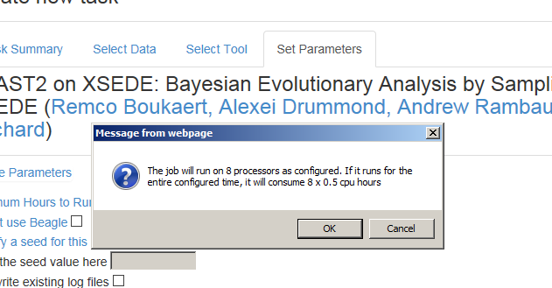

In code:
<warns>
<warn>
<message>The job will run on 8 processors as configured. If it runs for the entire configured time, it will consume 8 x $runtime cpu hours</message>
<language>perl</language>
<code>!$no_beagle &amp;&amp; $runtime ne 0 </code>
</warn>
<warn>
<message>The job will run on 8 processors as configured (jobs without BEAGLE run on a single processor. If it runs for the entire configured time, it will consume 1 x $runtime cpu hours</message>
<language>perl</language>
<code>$no_beagle &amp;&amp; $runtime ne 0 </code>
</warn>
</warns>

Configuring the Job run using hidden commands.
Pise XML makes it possible 1) to deliver hidden strings over which the user has no control (Section 2.3.2) and 2) to create auxiliary files that are used to deliver information to the job scheduler, or any other situation where an auxiliary file is used (Section 2.3.9.6). We use these two capabilities together to create the correct command line and a configuration file that will be delivered to the scheduler.

In CIPRES interfaces, the configuration of job runs is based on user input into the web form. This is because for complex code runs with input of variable size, efficiency of a parallel run is strongly influenced by the exact parameters submitted. These parameters can be made visible, for example the NeuroScience Gateway allows users to configure their own runs. How you use it depends both on your users, and your tolerance for configuration errors that may cause inefficient runs.

Here is an example of a run configuration specification:

This case shows how we use two hidden parameters to deliver the command line and create the scheduler.conf file with the correct information for this run. Scheduler,conf is delivered to the remote compute resource, and is used there to configure the run.

In this case, the interface specifies a pthreads version of the code, wheras other runs may require a hybrid code. This parameter creates the correct command line (calling a pthreads version) when the user has configured a run that does not require bootstrapping ($mulparambootstrap_seed and $bootstrap_seed) does not specify a specific number of runs ($specify_runs), and does not require high memory ($more_memory).

<!-- hybridlogic13
For all options where -N is not used (not -f d -x (bootstrap_seed) or -b (mulparambootstrap_seed xxx -N nnn;
and not -f d -N nnn (specify_runs) to be run on Comet in the shared queue, use pthreads version, 8 Pthreads in one node. -->
<!-- RUN THESE JOBS ON Comet in the shared queue -->
<parameter ishidden="1" type="String">
<name>raxmlhpc_hybridlogic13</name>
<attributes>
<format>
<language>perl</language>
<code>"raxmlHPC-PTHREADS_8.2.8 <!-- -T 12 -->"</code>
</format>
<precond>
<!-- deliver this line for any option that does not involve -f a or -f d -->
<language>perl</language>
<code>!$mulparambootstrap_seed &amp;&amp; !$bootstrap_seed &amp;&amp; !$specify_runs &amp;&amp; !$more_memory</code>
</precond>
<group>0</group>
</attributes>
</parameter>

The next parameter creates the scheduler,conf file and adds the correct configuration information to that file. In this case, for the case where the user has configured a run that does not require bootstrapping. Since the pthreads code runs differently than the hybrid code, yhis parameter creates the scheduler,conf file, and adds the correct configuration information when the user has configured a run that does not require bootstrapping ($mulparambootstrap_seed and $bootstrap_seed) does not specify a specific number of runs ($specify_runs), and does not require high memory ($more_memory). The text put into the scheduler.conf file will depend upon the specific scheduler, machine, and the run requirements. The scheduler.conf file is read on the submission host, and is used to prepare a submission script. In the case below it specifies threads, allows submission to a shared node, and requests a single node.

<!-- add a statement to run job on Comet in the shared queue-->
<parameter ishidden="1" type="String">
<name>raxmlhpc_hybridlogic13b_scheduler</name>
<attributes>
<paramfile>scheduler.conf</paramfile>
<format>
<language>perl</language>
<code>"threads_per_process=12\\n" .
"node_exclusive=0\\n" .
"nodes=1\\n"
</code>
</format>
<precond>
<!-- must be -f d -x or -b AND use_bootstopping -->
<language>perl</language>
<code>!$mulparambootstrap_seed &amp;&amp; !$bootstrap_seed &amp;&amp; !$specify_runs &amp;&amp; !$more_memory</code>
</precond>
<group>0</group>
</attributes>
</parameter>

Code Elements (Perl) in Pise and CIPRES

These are modifier elements that help construct the command line using code. These elements are flagged by the <language> element (currently, always as 'perl').

This allows the PiseCommandRenderer to find the fragment of the command to be created.

Perl allowed in CIPRES.

Code elements:

In CIPRES, code is used in only three places, <precond>, <format> and <ctrl> elements. Perl statements that can be used are limited and there are subtle differences in how perl statements are handled in each of the three element types.

<format> and <precond> elements are evaluated by the

PiseCommandRenderer.restituteFormat and

PiseCommandRenderer.restitutePreCond methods.

<ctrl> are handled by freemarker templates, which translate them into javascript. In the future they may also be used to create Java validator classes.

Within <format>, the PiseCommandRenderer does the following:

- replace $parameter, $value and $vdef with their values.

- replace "defined $value", “defined $vdef", "defined $parameter" with 1 or 0
  - defined $value = 1, except in hidden parameters.
  - defined $vdef = 1, if a default is specified in the xml.
  - defined $parameter = 1 if parameter is in the parameter map, 0 otherwise

- will replace (a) ? b : c with (a) ? print b : print c, but does not handle more than one question mark operation in the expression; you'll get garbage if you use more than one.

- if the expression doesn't contain a ? op, it prefixes the whole expression with "print".

- passes the resulting expression to "perl -e".

- You need to make sure whatever is going to be passed to print (i.e. whatever the b and c parts of a ? op, or the whole expression if no ? used) is within quote marks so that print sees it a a string. Thus <code>$value</code> is wrong, <code>"$value"</code> is right.

- Hidden elements can be used to force some code to be generated without depending on the user entering data for the parameter.

- Hidden elements do not appear in the parameter map, therefore $value should never be referenced within the code of a hidden element (it will be null and generate an error).

- Hint: if you want to put a newline in a parmeter file, for instance, use \\n in the format code.

< precond> restitution is a little different

- variables and "defined" expressions are replaced, as above.

- the whole expression you write, X, is rewritten as (X) ? print "true" : print "false" and the code in PiseCommandRenederer that evaluates the precond looks for the string "true" or "false" to decide if the precond is true or false.

- since your expression X will be evaluated as a Boolean, you don't put it in quotes.

- If you want an empty string, for instance if you want the default value for a parameter to be the empty string use

<vdef></vdef> and not <vdef>""</vdef>

The later will give you a string of length 2, containing two double quotes.

- If a parameter is of type InFile (or String) and you reference $param_name in a code element,
  - $param_name will be replaced with the contents of the file (or whatever the user typed in for the String) in the perl expression. This can easily create an invalid perl statement that will cause an error.
  - You should probably instead check "defined $param_name" to see if the user chose a file or entered any data.

The command renderer will not necessarily process the code elements for all parameters
that appear in the Pise XML file. It will process 3 sets of parameters:
- Those that are set via the gui and thus appear in the input parameter map the gui sends
- Those that are declared ishidden in the Pise XML
- Those that are declared of type OutFile or Result.

General:

If you don't even open the gui it sends everything with its default value except
hidden parameters. I'm not sure what happens if there is no default specified. Ask
Jeremy. Jeremy is working on changing this so that parameters whose precond aren't met will not be included in the map. Ask Jeremy for status.

If you open the gui but don't edit anything, it does the same as above except that it
doesn't send parameters whose preconditions aren't met.

So, a parameter will be missing from the map if its <precond> isn't met, or if the user
clears the value of a non-mandatory parameter, or if it has no default value .

Hidden parameters are always processed, though we don't receive values for them in
the map. $value will always be null; referencing it will throw an exception.

$vdef is set if there is a vdef in the Pise XML for the parameter, null otherwise.

Wildcards to specify output files (or type="Results"):

There is a very limited wildcard implementation, you can only use it to specify that all files with a certain suffix should be treated as results, like "*.gif" or "*.jpg". You cannot use it to specify a prefix (like "outfile.*") or a pattern that doesn't include a "." (like *fish) or anything else.

Using paragraphs for grouping of controls: If you make a parameter within a paragraph
issimple, that parameter will show up in the "simple parameters" section outside of
any paragraphs, but according to Rami, if you make the whole paragraph issimple and each of the parameters within it is also issimple, they'll all show up together as a paragraph in the issimple section.

EXAMPLE OF HOW TO TEST A PERL STATEMENT

perl -e 'print "hi there"'

The single quotes are so that the full print statement is passed to perl as a single argument. The double quotes are because "print" expects a single string argume there are special variables that you can use in the code.

$value | entered value of the current parameter
$vdef | default value of the current parameter
$<variable>: | where <variable> is the name that you have given to the parameter

$value == $vdef means that the user did not change the proposed value

PISE: $value is not defined (perl) when not entered by the user. This is useful to distinguish a zero value from a non entered value for integers (cf B parameter of Blast)

CIPRES: we can’t handle this the same way, not defined is meaningless (recent change in PiseCommandRenderer uses defined to be check for completeness)

PISE: the code is always evaluated in an evaluation name space (see the file lib/evaluation.pl) in order to protect the name space of the interface itself

CIPRES: the code is evaluated within the PiseCommandRenderer Class. This Class calls “perl –e “ to evaluate the perl statements. Therefore, all variables are restituted by their values before the evaluation.

<format>
<language>perl</language>
<code>($value > 10)? " -f $sup " : " -f "inf" </code>
</format>

General Perl code
Pise XML: the code is intended for the RHS of an affectation

examples (in perl):
' " -f $value" '
will be used as (if the name of the variable is file):
$file = " -f $value"
others examples:
' " E=$expect" '
CIPRES: not used

Conditional assignation:
'($value > 10)? " -f $sup " : " -f "inf" '

Note: you must explicitly give the separator (even a space) between parameters , the PiseCommandRenderer will not put it for you.

<precond>
<language>perl</language>
<code>$plotter eq "L"</code>
</precond>

Same rules as format, except that it's used in a test
example:
'$e < 4'
will be used as:
if ($e < 4)

<ctrls>
<ctrl>
<message>Please enter a value between 0 and 1.</message>
<language>perl</language>
<code>$value &lt; 0 || $value &gt;= 1</code>
</ctrl>
</ctrls>

<flist>
<value>v1</value>
<code>" -F \"m S\""</code>
<value>v2</value>
<code>" -F C"</code>
<value>v3</value>
<code>" -F \"C;S\""</code>
<value>v4</value>
<code>" -F D"</code>
<value>v5</value>
<code>" -F m"</code>
</flist>

flist (list of formats for different values, useful for parameters like Excl, List, ...)

CIPRES: for multiple choices we didn’t implement to handle the multiple generation of flist values (could be tested)

In PiseCommandRenderer: flist and format are mutually exclusive

Appendix A: Using Modular Data Base Files

Database access is accomplished by calling specific reusable pieces of Pise XML code from a specific or implied address. The snippets are complete elements that will be called into a Pise XML file.

Data base files are referred to by one of two conventions. They can specify an explicit address, or they can take advantage of environment variables that have been set during tool installation. The latter case is used when an installed tool sets these environmental variable for you. The thinking here is that while we could set up environmental variables for every single tool, it is extra work with no obvious benefit. Also, it would add a level of complexity for relocating the application.

In the case where an explicit address is used, it might look like this:

<code> " -d /isilon/ngbw/8ball/BLASTDB/$value" </code>

Which directs the application to the BlastDB database.

In the case where environmental variable are used, the reference to a database reference looks like this; where the called in code simple provides a drop down box, and the command line values used to access the selected DBs.

<vlist>
<value>GBMAM</value>
<label>GBMAM: other mammals</label>

<value>GBBCT</value>
<label>GBBCT: genbank bacteria</label>

<value>GBENV</value>
<label>GBENV </label>

<value>GBEST</value>
<label>GBEST: EST (Expressed Sequence Tags)</label>

<value>GBGSS</value>
<label>GBGSS: Genome Survey Sequences</label>

<value>GBHTC</value>
<label>GBHTC </label>

<value>GBHTG</value>
<label>GBHTG: GS (high throughput Genomic Sequencing)</label>

<value>GBPAT</value>
<label>GBPAT: patented</label>

<value>GBINV</value>
<label>GBINV: invertebrates</label>

<value>GBPHG</value>
<label>GBPHG: phages</label>

<value>GBPLN</value>
<label>GBPLN: plants (including yeast)</label>

<value>GBPRI</value>
<label>GBPRI: primates</label>

<value>GBROD</value>
<label>GBROD: rodents</label>

<value>GBSTS</value>
<label>GBSTS: STS (Sequence Tagged sites)</label>

<value>GBSYN</value>
<label>GBSYN: synthetic</label>

<value>GBUNA</value>
<label>GBUNA: unannotated</label>

<value>GBVRL</value>
<label>GBVRL: virus</label>

<value>GBVRT</value>
<label>GBVRT: other vertebrates</label>

</vlist>

Appendix B: PISE XML Schema Representation:

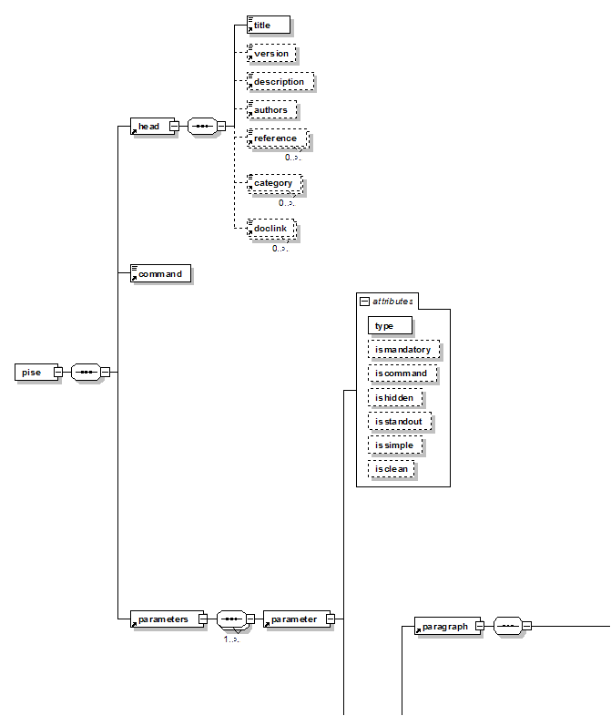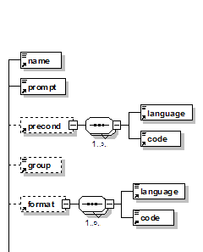
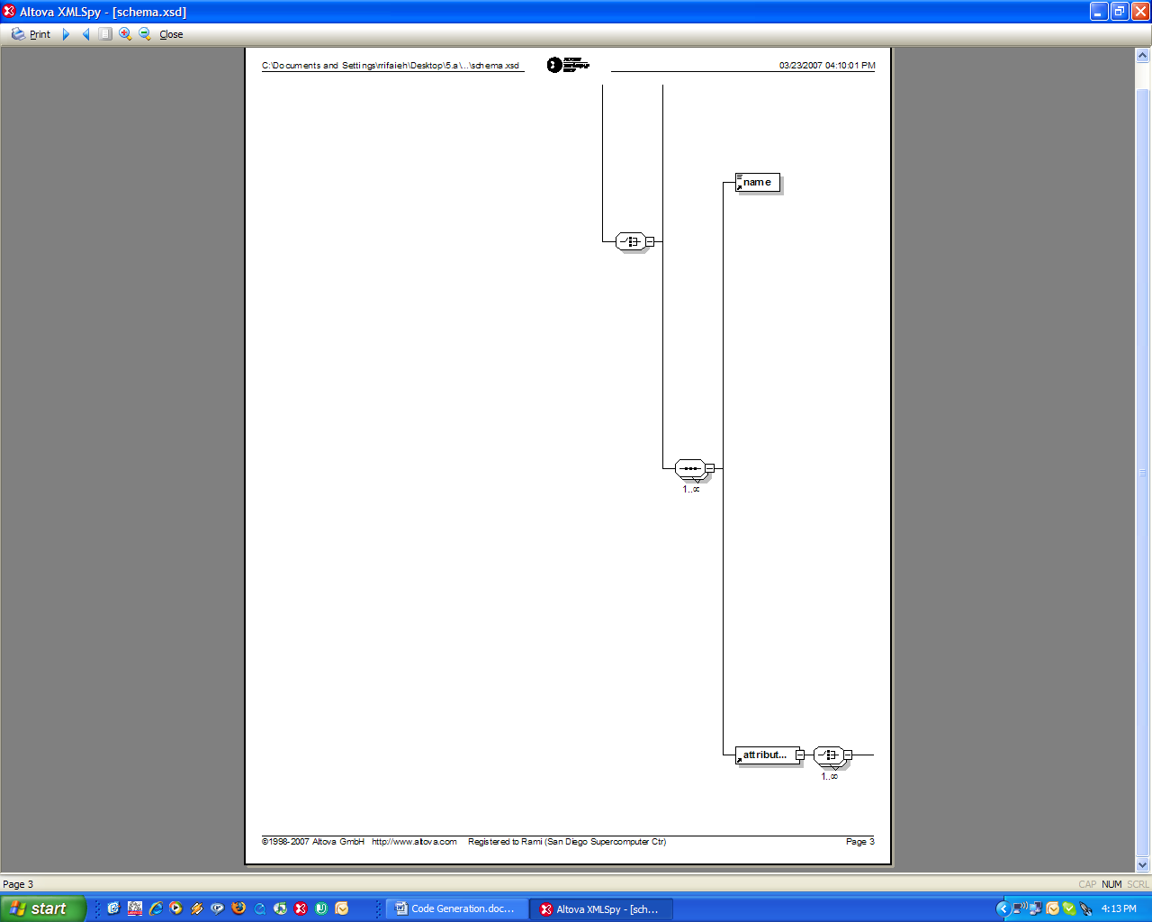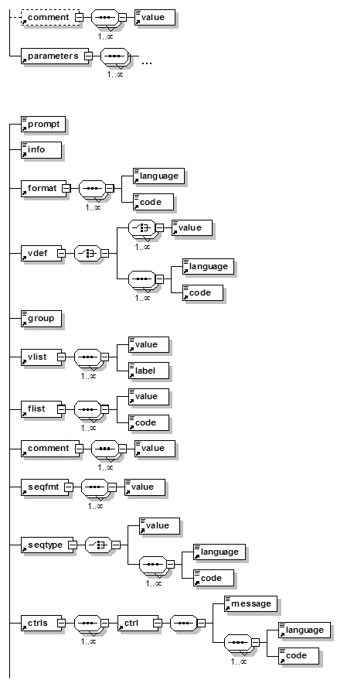
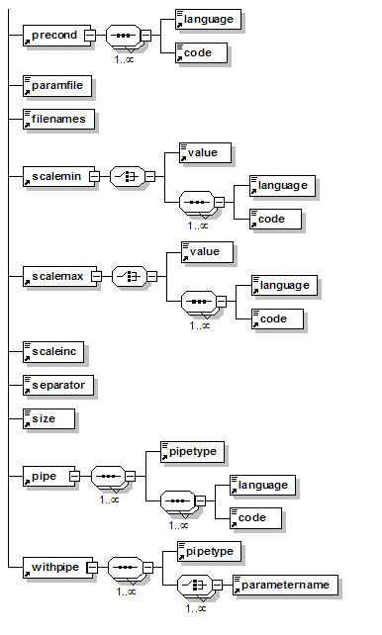

Appendix C: MOBYLE XML Schema Representation:

